Comprehensive Guide to 20 Essential Data Visualization Charts

# Histogram

This section includes a visualization for Histogram.

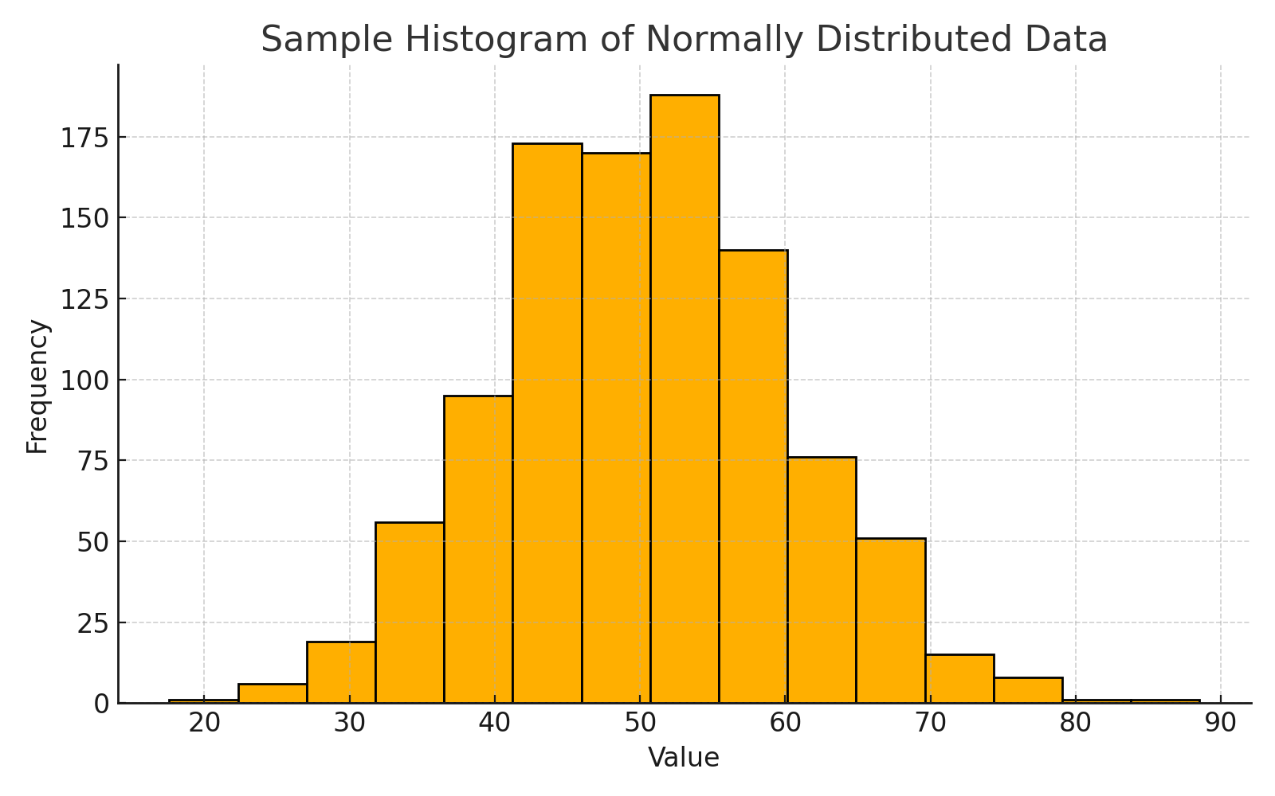

# Box Plot

This section includes a visualization for Box Plot.

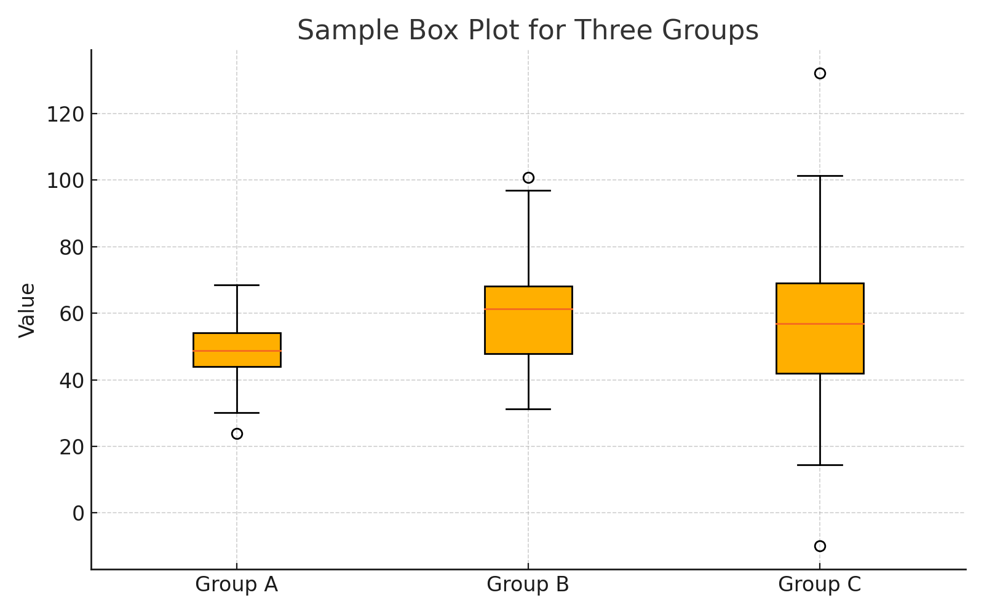

# Violin Plot

This section includes a visualization for Violin Plot.

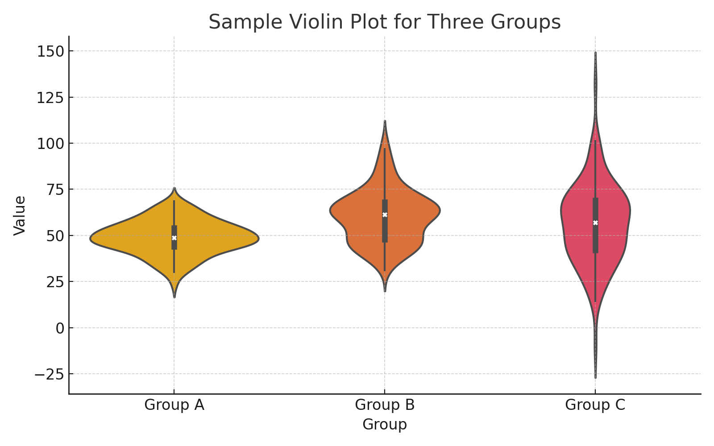

# Density Plot

This section includes a visualization for Density Plot.

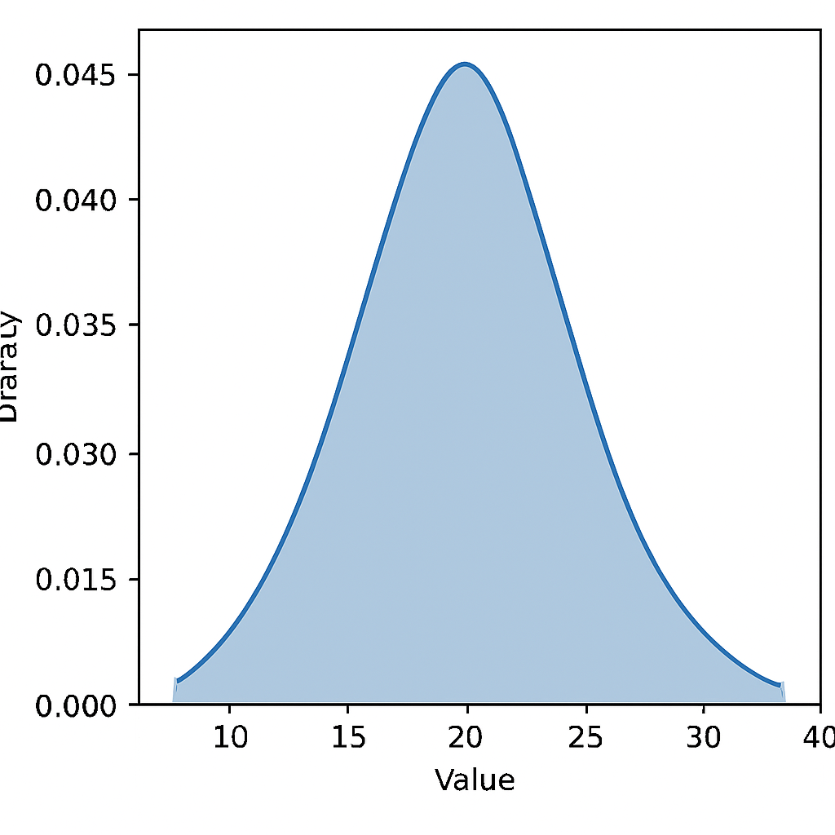

# Bar Chart

This section includes a visualization for Bar Chart.

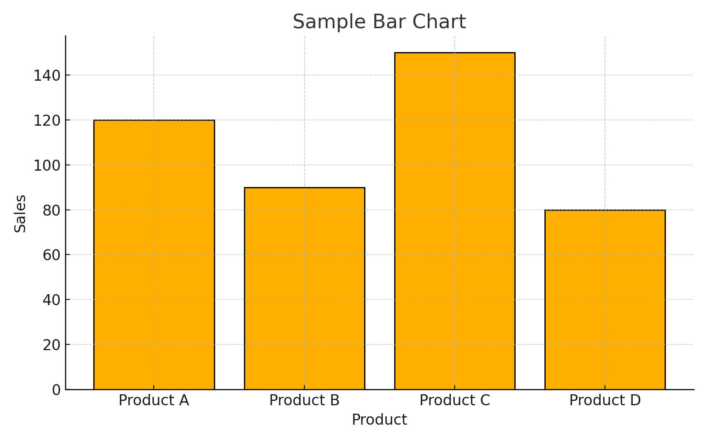

# Grouped Bar Chart

This section includes a visualization for Grouped Bar Chart.

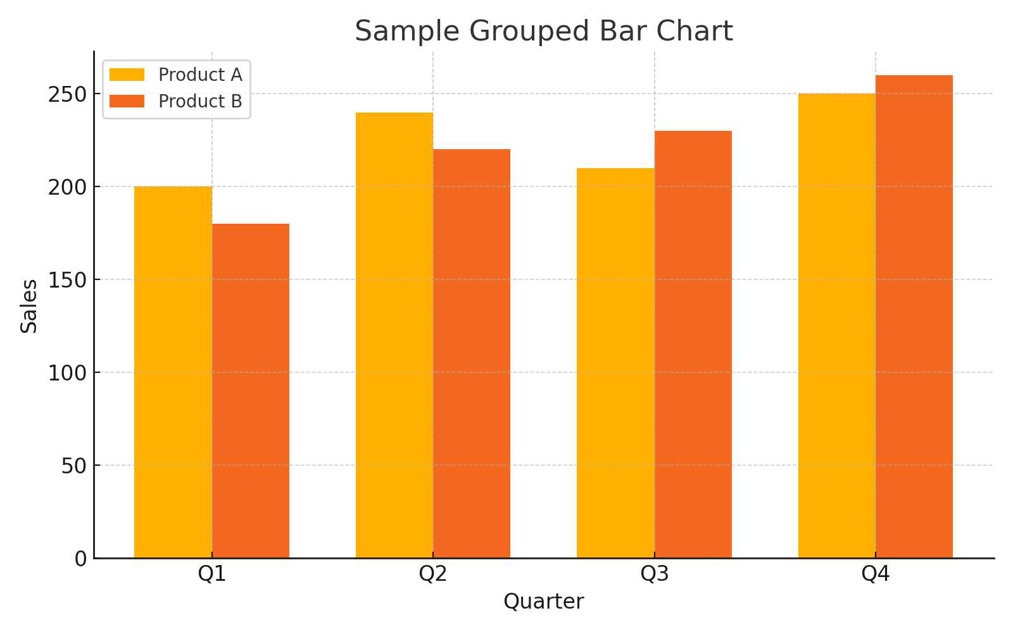

# Stacked Bar Chart

This section includes a visualization for Stacked Bar Chart.

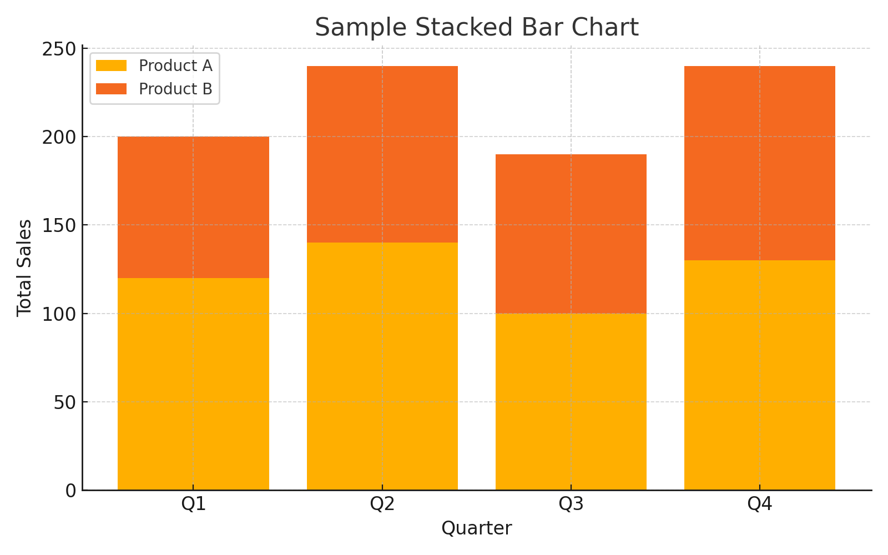

# Dot Plot

This section includes a visualization for Dot Plot.

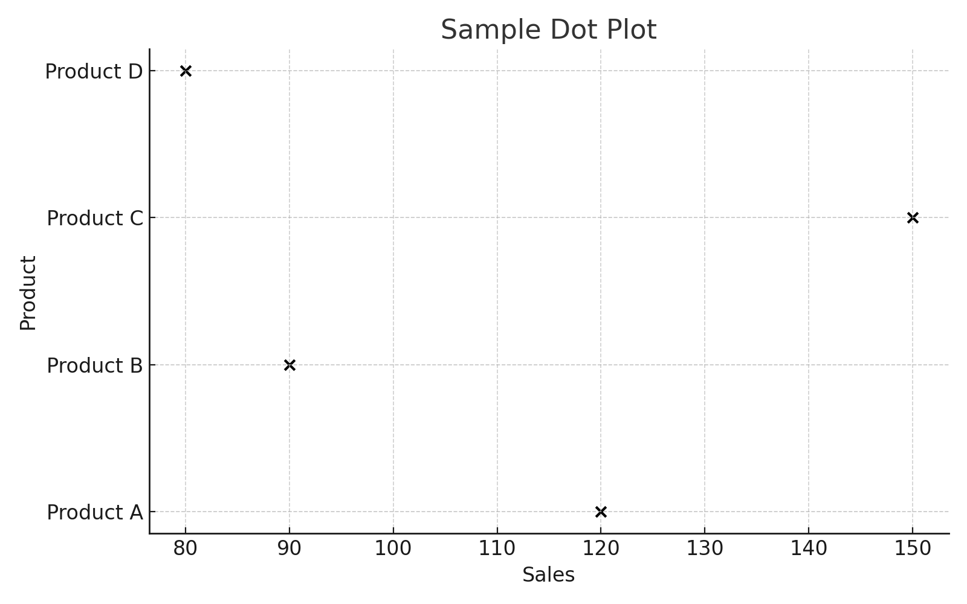

# Pie Chart

This section includes a visualization for Pie Chart.

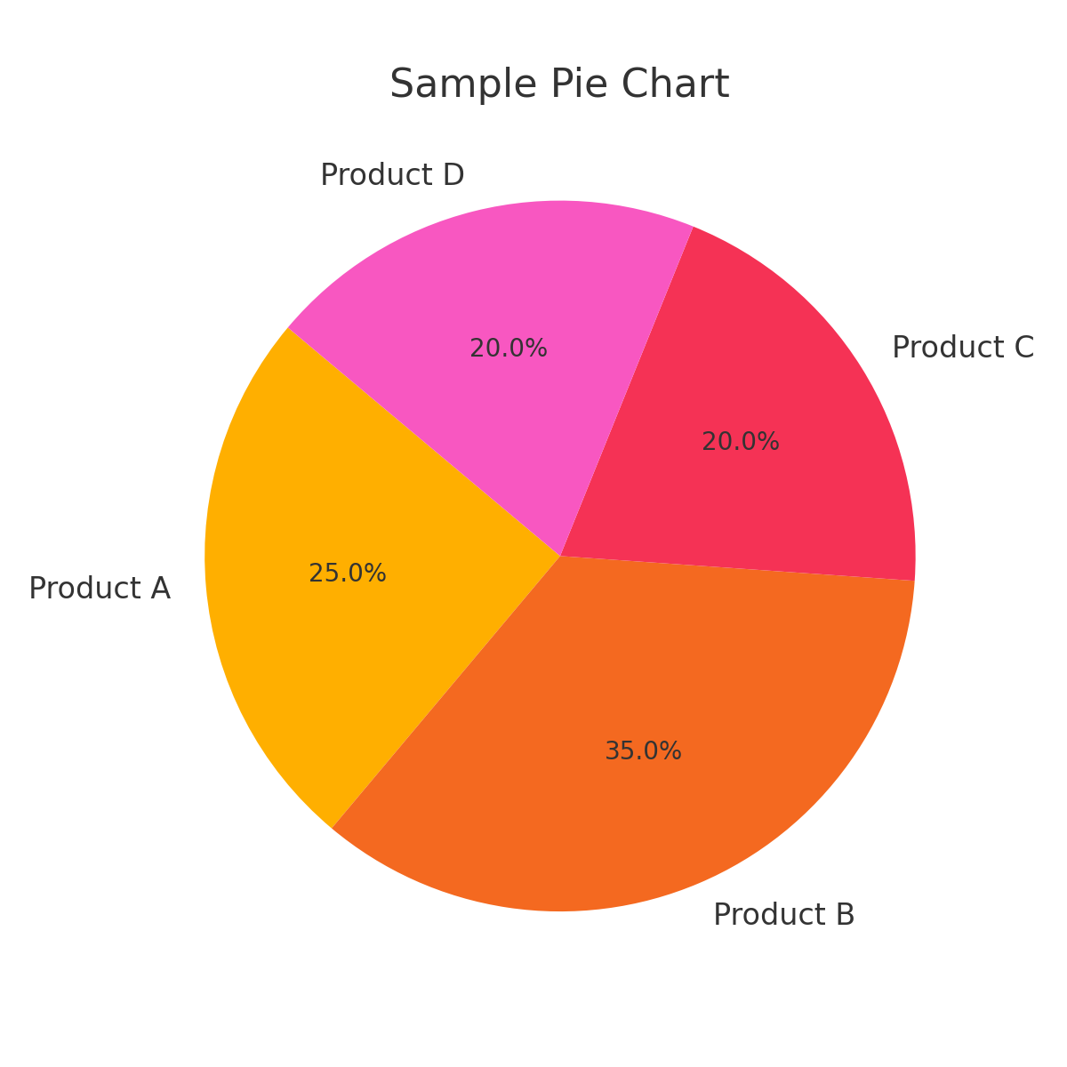

# Donut Chart

This section includes a visualization for Donut Chart.

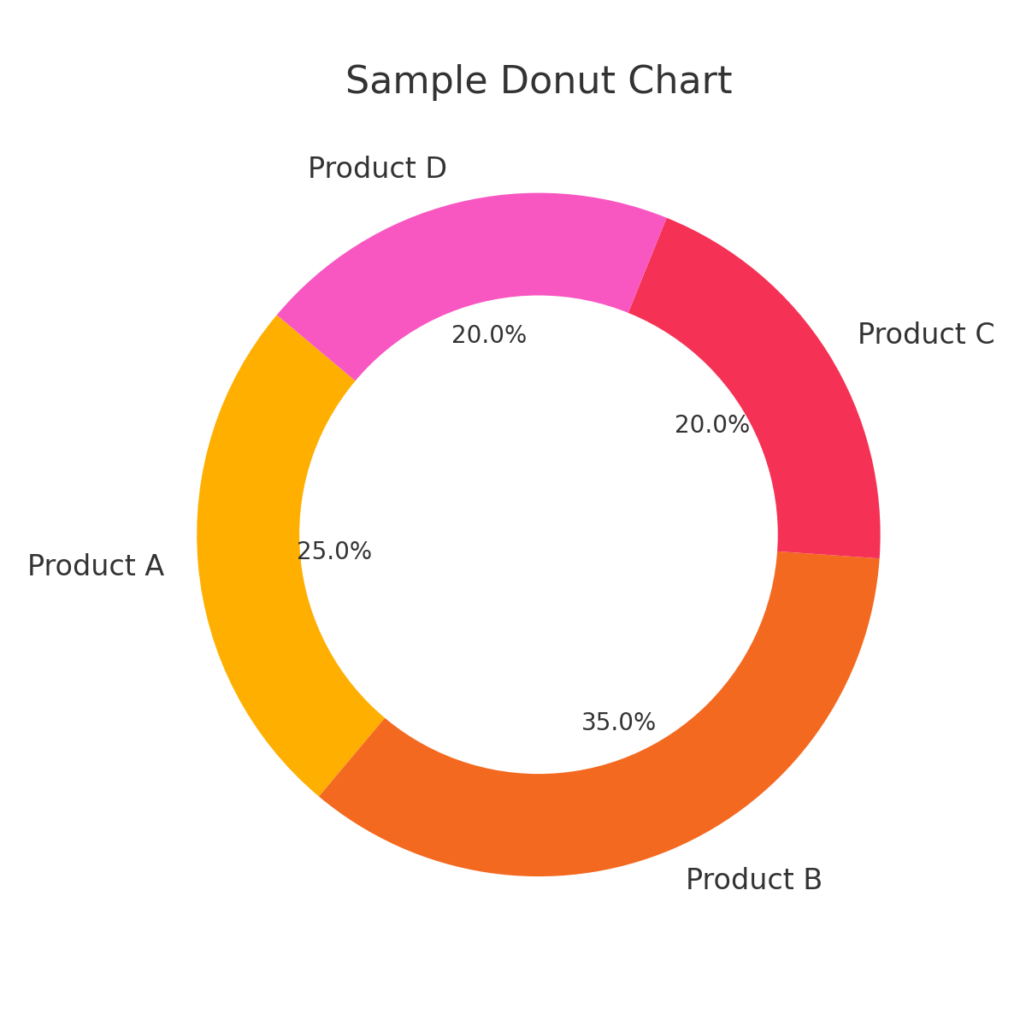

# Treemap

This section includes a visualization for Treemap.

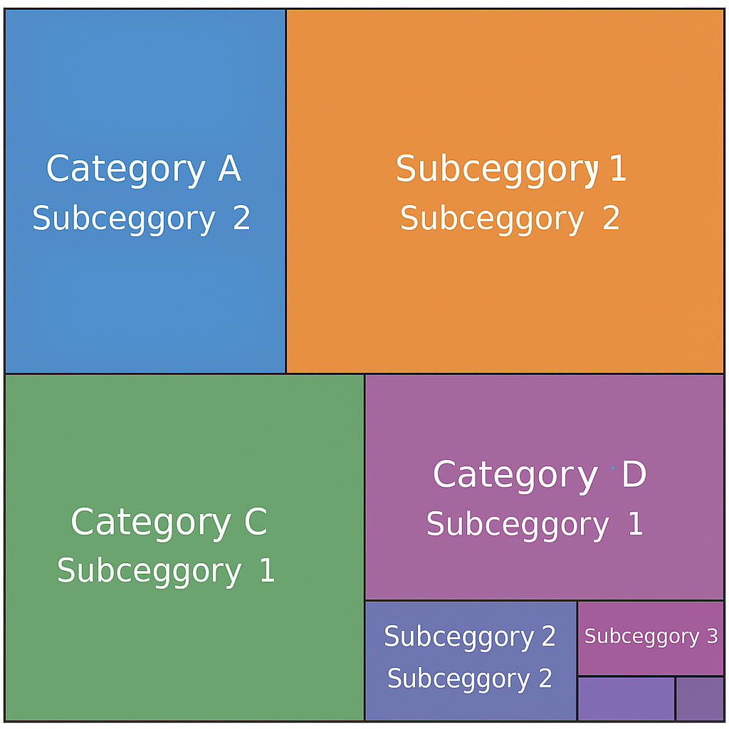

# Stacked Area Chart

This section includes a visualization for Stacked Area Chart.

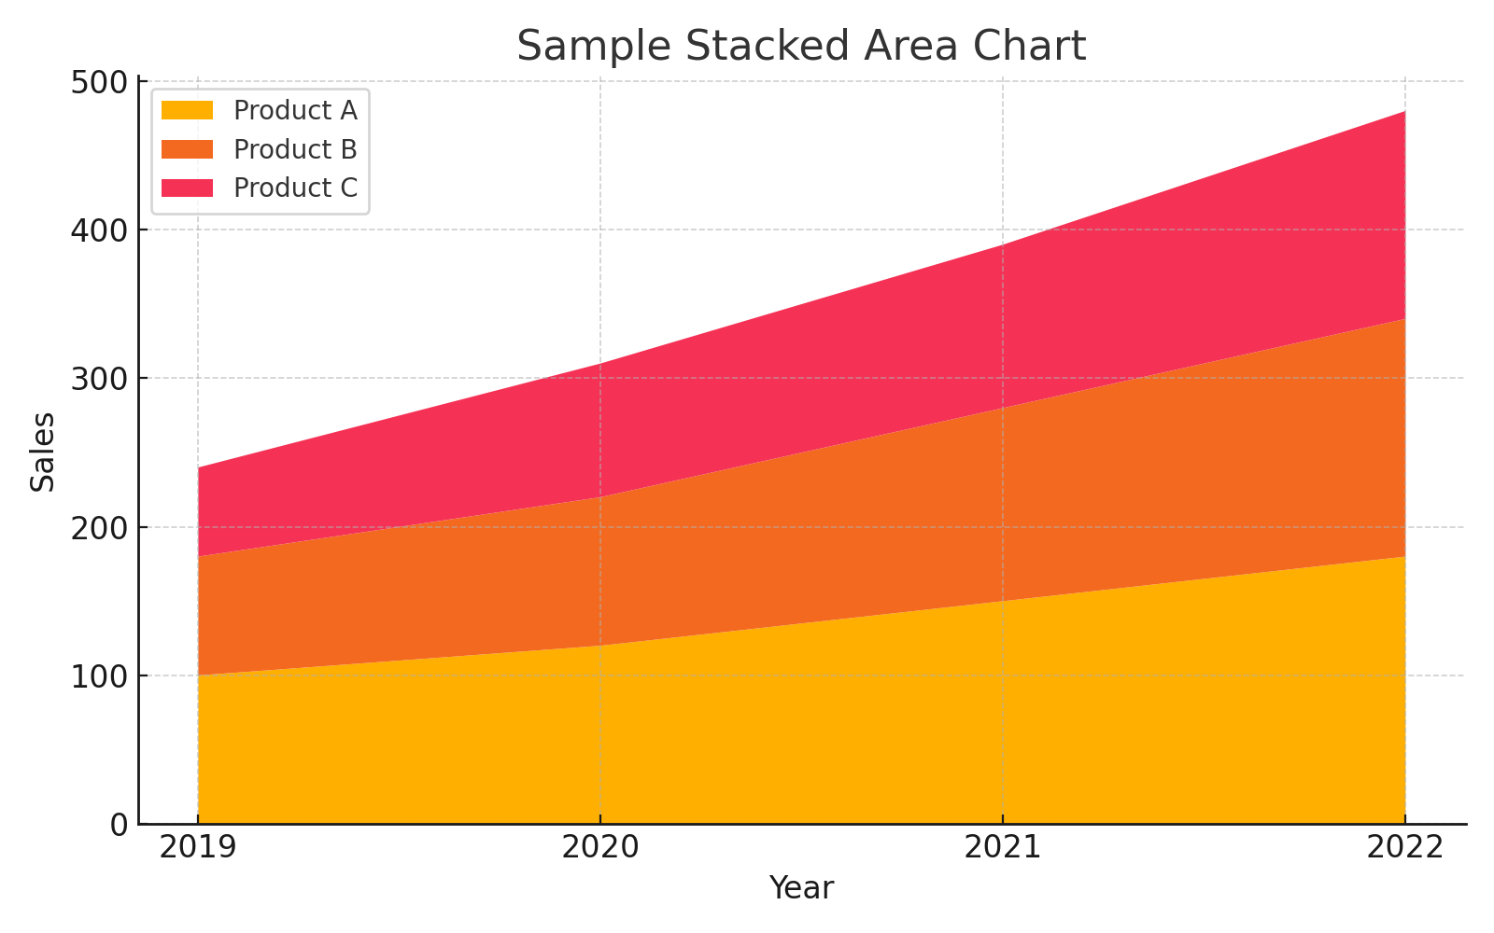

# Scatter Plot

This section includes a visualization for Scatter Plot.

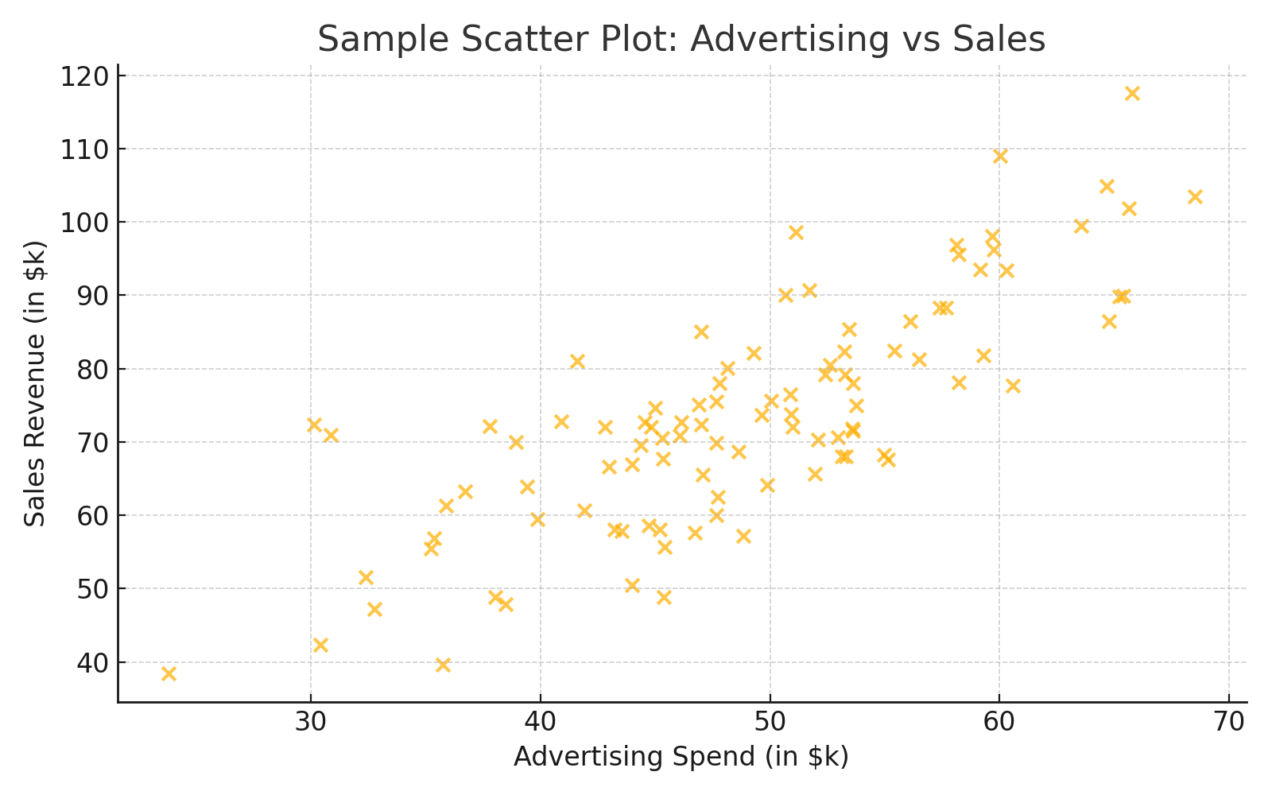

# Bubble Chart

This section includes a visualization for Bubble Chart.

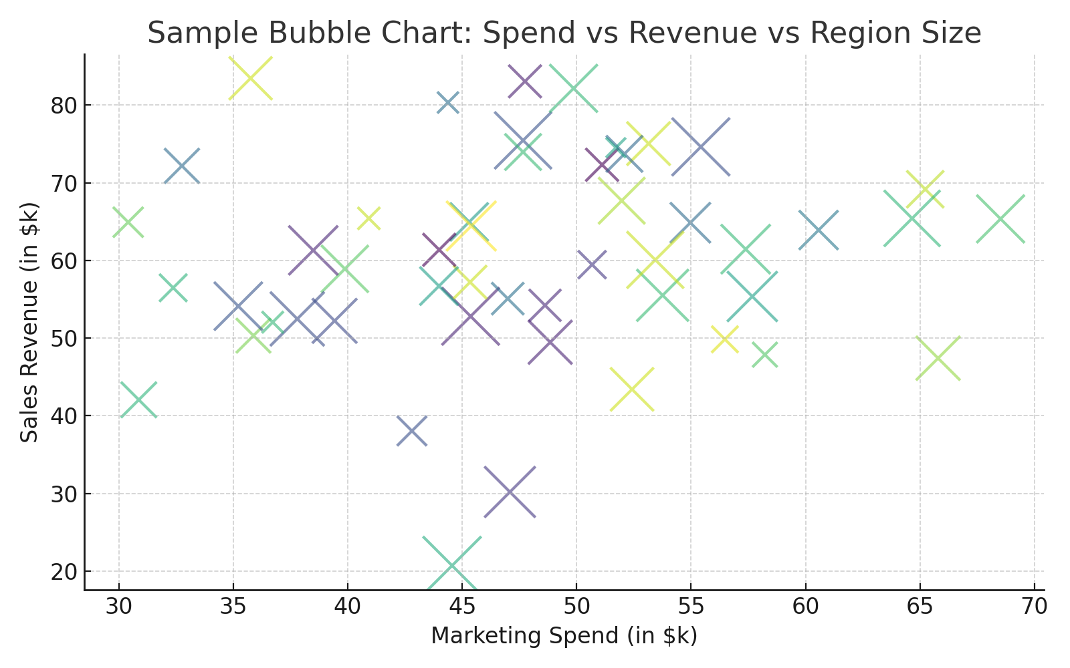

# Heatmap

This section includes a visualization for Heatmap.

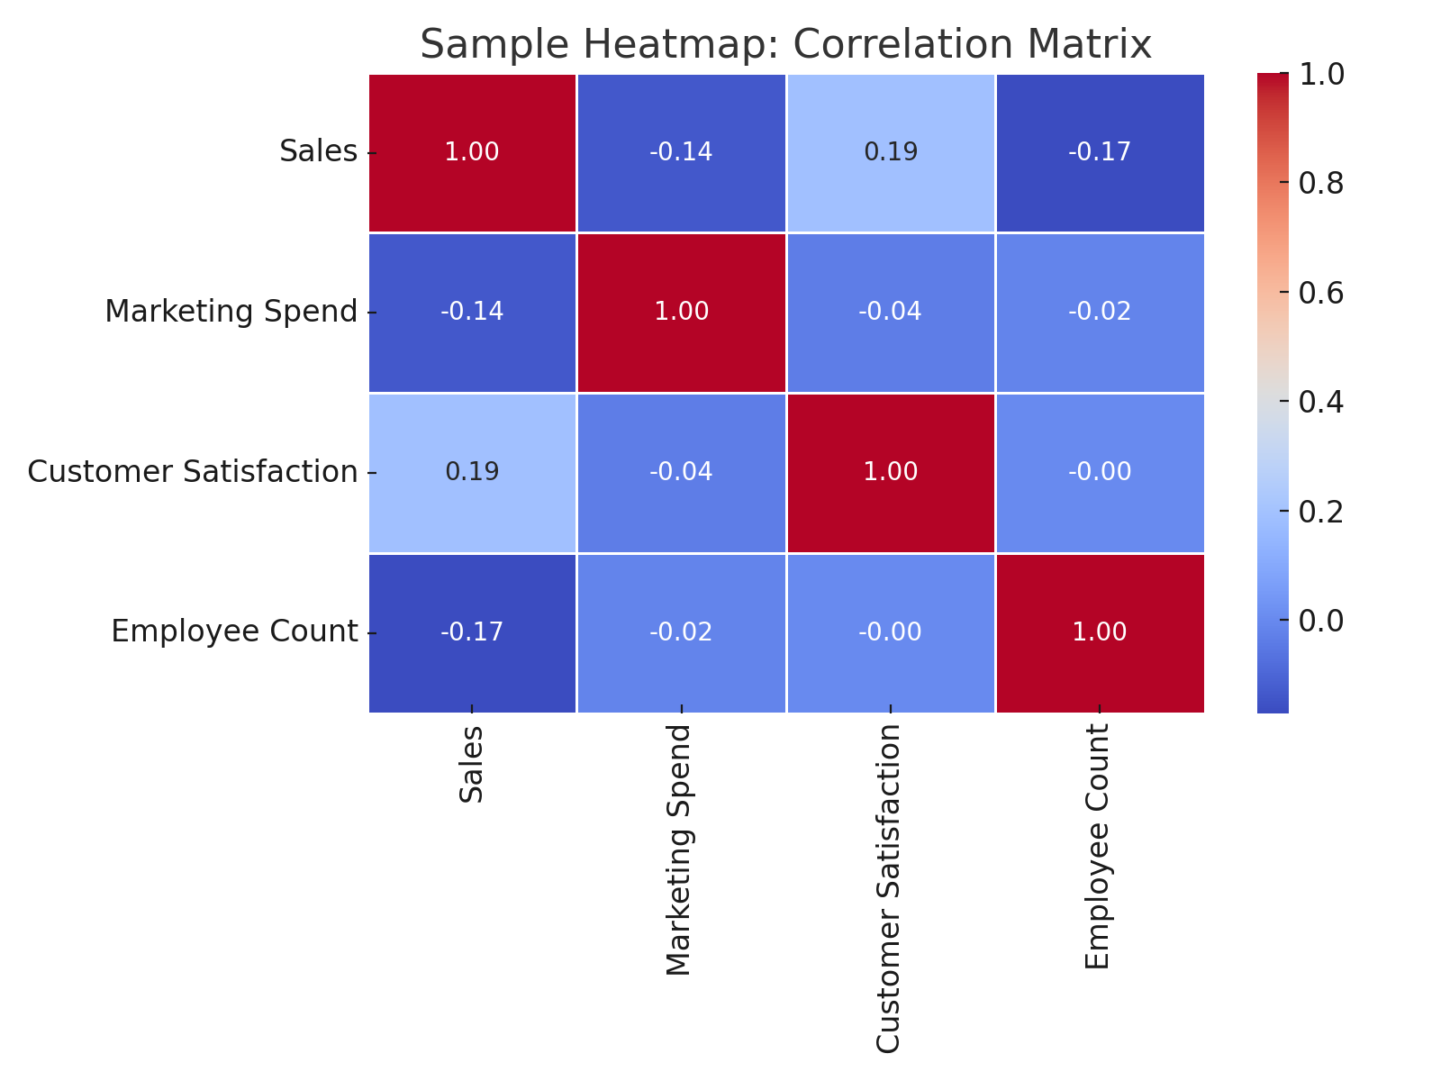

# Pair Plot

This section includes a visualization for Pair Plot.

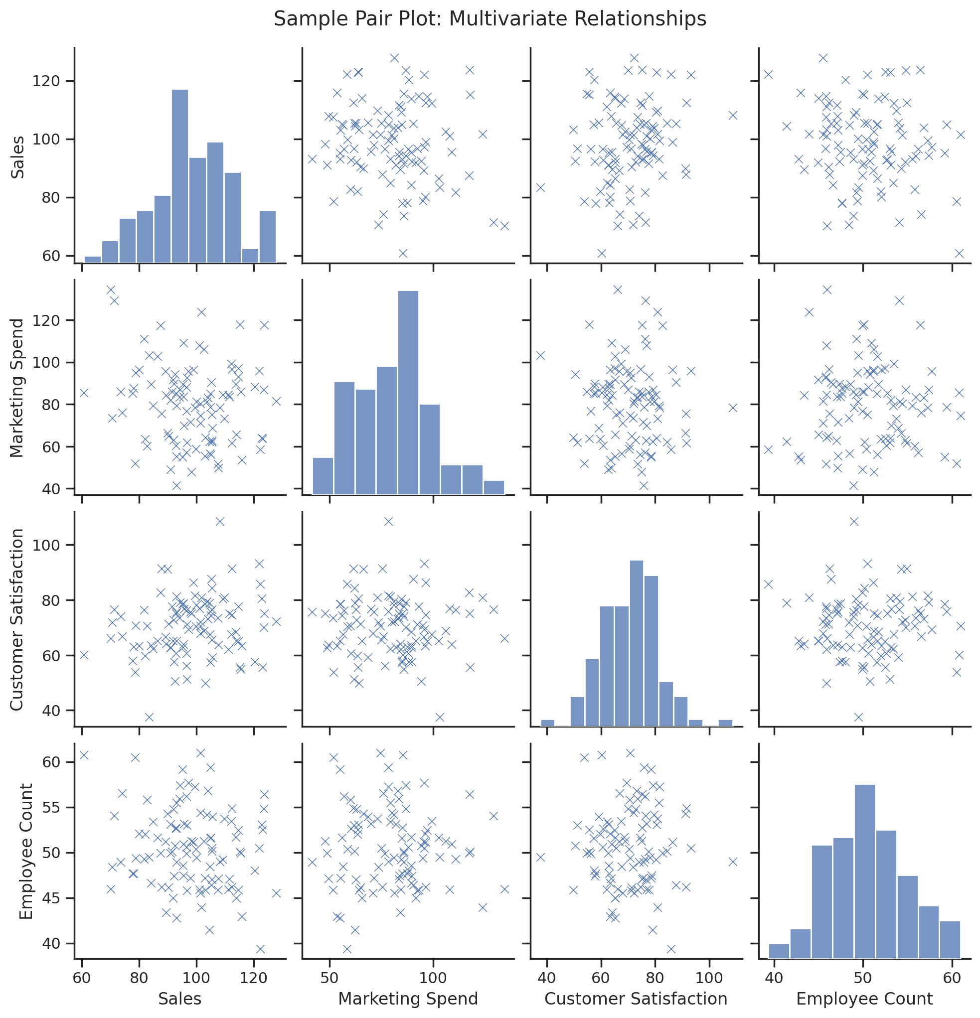

# Line Chart

This section includes a visualization for Line Chart.

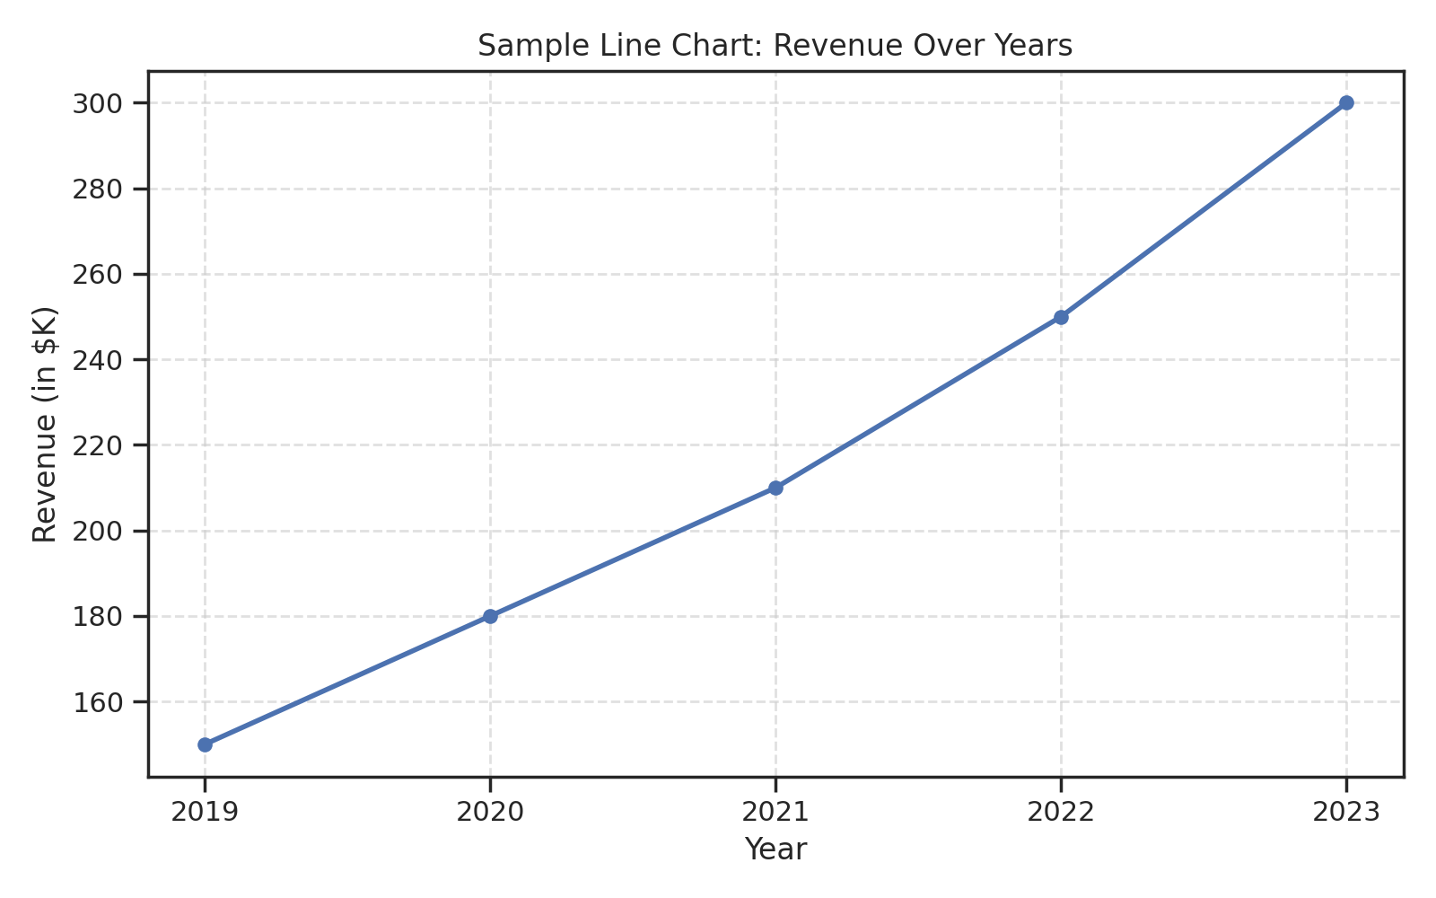

# Multi-Line Chart

This section includes a visualization for Multi-Line Chart.

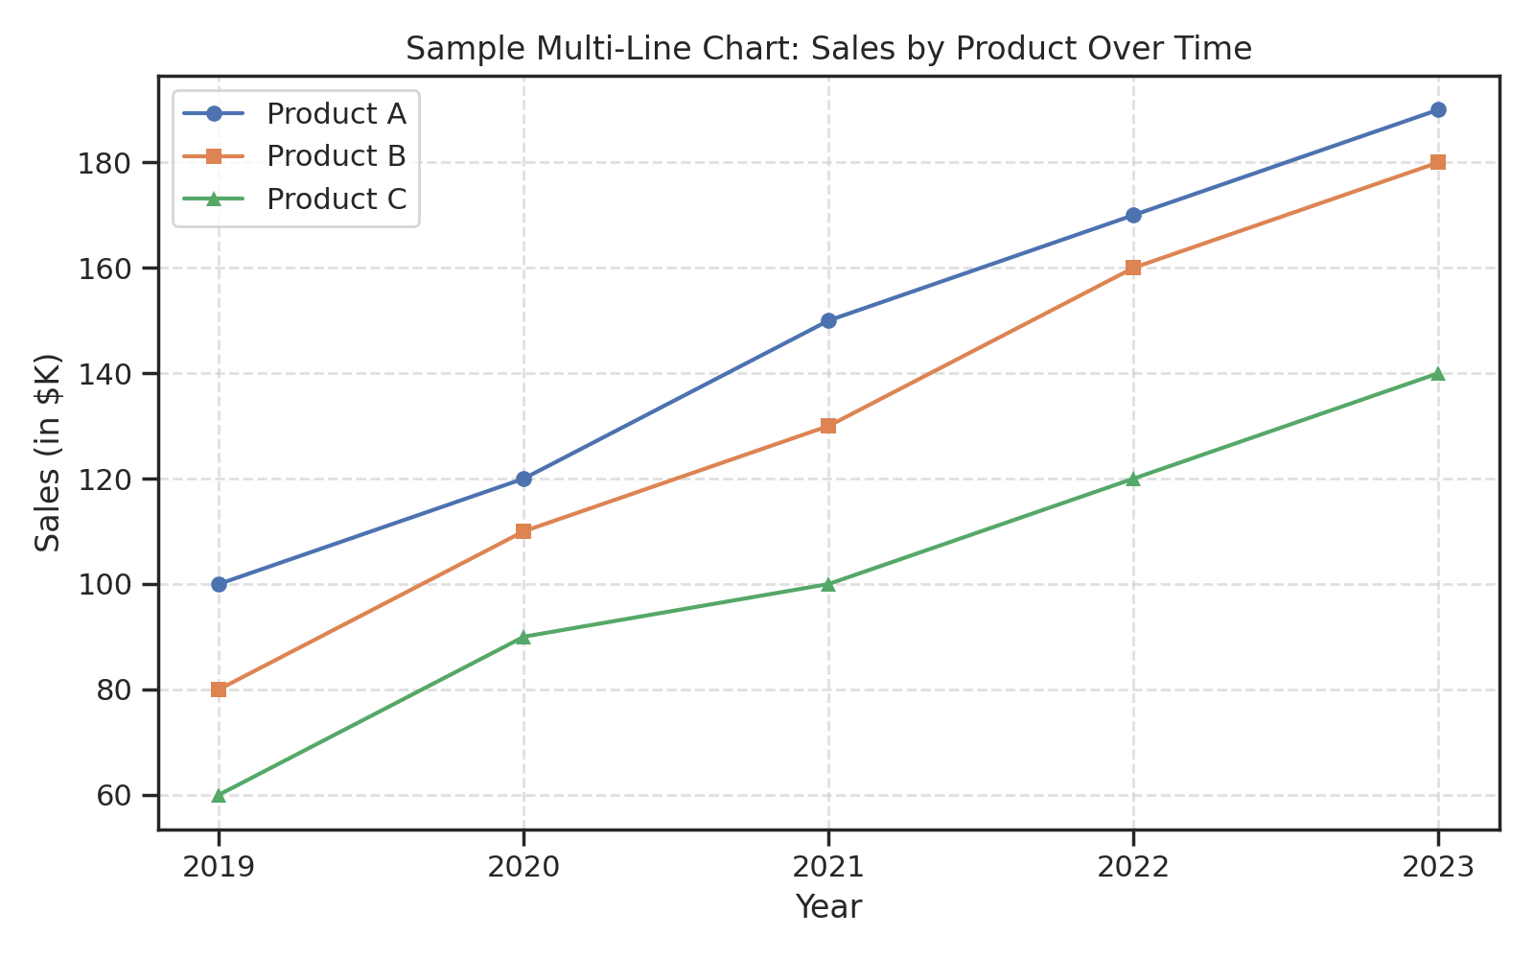

# Time Series Decomposition Plot

This section includes a visualization for Time Series Decomposition Plot.

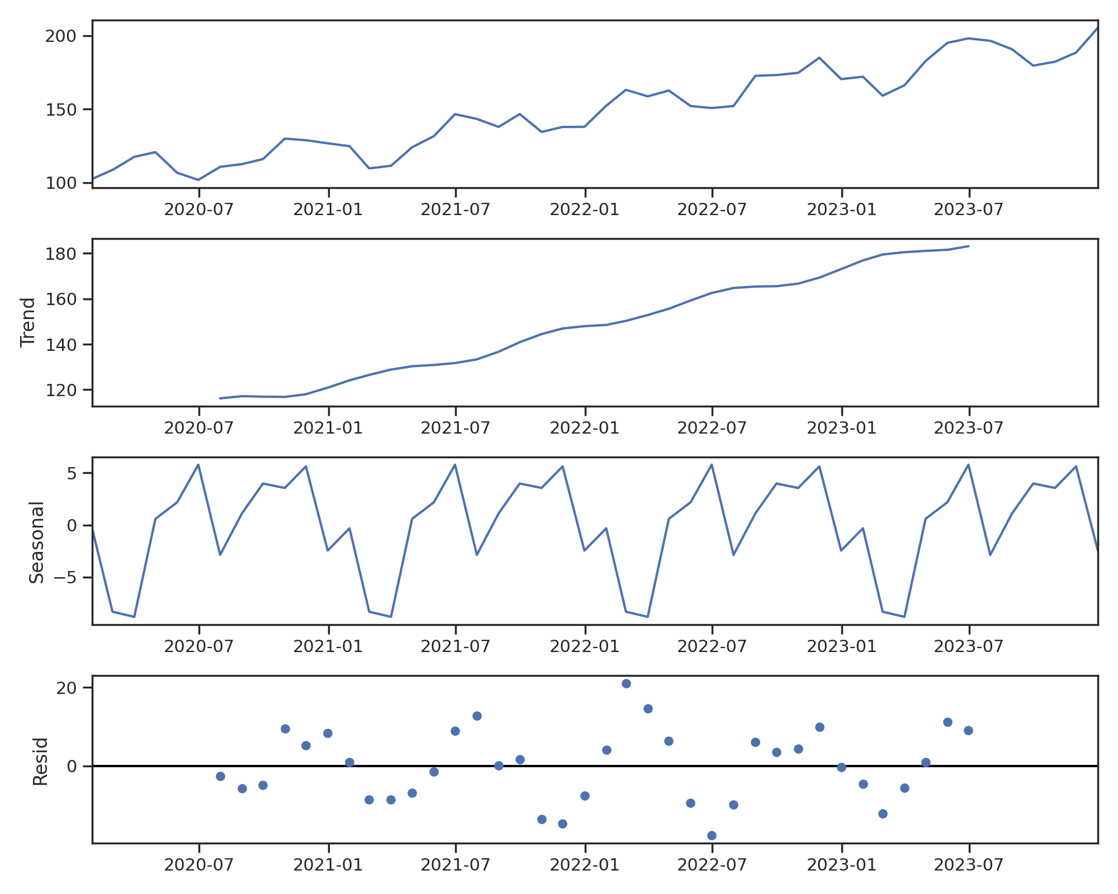

# Radar Chart

This section includes a visualization for Radar Chart.

